# **System Overview**

The Baby Steps Uganda system is a comprehensive digital learning platform designed to enhance early childhood education by integrating traditional Ugandan cultural elements in an engaging, interactive format. The system aims to provide young children with exposure to indigenous languages, traditional stories, and games, ensuring that cultural knowledge is passed down to future generations in an interactive and modernized manner.

The development of the Baby Steps Uganda system was initiated in response to the growing need for early cultural education in Uganda. Studies suggest that exposure to cultural heritage at a young age significantly enhances cognitive abilities, language retention, and social development [1]. This system builds upon existing research in early childhood education, cognitive psychology, and digital learning methodologies to provide an immersive and structured learning experience for young children [2].

Uganda is home to diverse cultures, languages, and traditions that play a crucial role in shaping national identity. However, many children grow up without exposure to these cultural elements due to urbanization, modernization, and a shift towards Western educational frameworks. The Baby Steps Uganda system addresses this challenge by providing an accessible platform where parents, educators, and caregivers can introduce children to Ugandan heritage through engaging and interactive digital content.

The system will provide the following functions: -

* **Interactive cultural Learning Modules**:  The system shall offer a variety of cultural-rich modules featuring traditional stories,  language teaching modules, and cultural activities tailored for early learners.
* **Language Immersion:** Through voiceovers and interactive dialogues, the system shall help children develop listening and speaking skills in Luganda.
* **Personalized Learning Paths**: The system shall provide customized learning experiences based on a child's progress and preferences, ensuring an adaptive and engaging experience.
* **Parental Dashboard**: The system shall include a monitoring dashboard where parents can track a child's progress, set learning goals, and access supplementary educational resources.
* **Gamified Experience**: The platform will feature rewards and achievements to keep children motivated as they engage with the content.
* **Offline Access**: The system will offer offline capabilities, allowing children in areas with limited internet access to continue learning seamlessly.

## Design

# **System Architecture**

## **Architectural Design**

Figure 3.1 shows the architecture of the system. 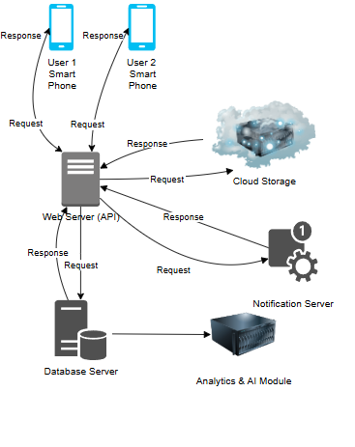

### *Fig 3.1: Deployment diagram of the IECLA*

The architecture is composed of the following:-

* User Devices (Mobile Smart Phones): The end users i.e., Parents and children interact with the system using a smart application on their mobile devices. These users send requests to the web server to retrieve or input their data and then receive responses that include; access to stories, language teaching modules etc.
* Web Server (Application Backend -API Layer): This is the brain of the system as it handles the business logic and all requests from the users of the smart application. After authenticating a user it then processes there requests by fetching their user profile, progress and previous app interactions. After which it sends data to and from the database.
* Database Server: After initial processing, the data is sent from the web server to a remote database. This database securely stores all structured data for the system i.e., user profiles, progress, and learning preferences. It also stores text-based learning materials such as stories and language exercises while ensuring data integrity and security.
* Cloud Storage/CDN: This is a remote server that stores and delivers large multimedia content effectively. It hosts audio recordings, videos and app assets. It also uses a Content Delivery Network (CDN) to distribute content quickly. This reduces the time it takes for users to retrieve multimedia i.e., responses by serving multimedia from servers closest to users
* Notification Server: This sends real-time reminders and alerts to users by using Firebase Cloud Messaging (FCM) to push these notifications. These alert users about new stories, new games, and daily learning goals. It also sends reminders to parents about progress reports.
* Analytics & AI Module: Monitors user engagement while also providing personalized recommendations. This is done by collecting interaction data (which app features a child interacts with, how long, accuracy). By using this information, it then recommends tailored content and also generates reports on learning progress for parents.

## Decomposition Description

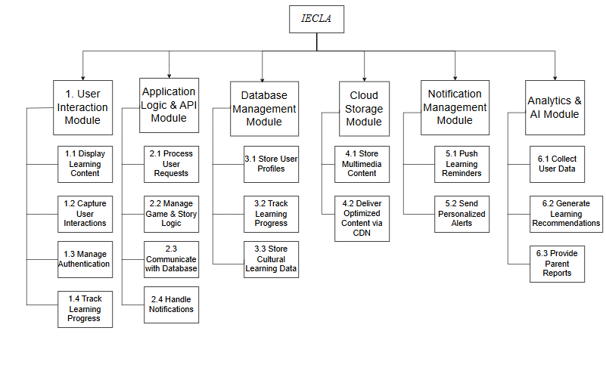

It encompasses key areas such as **user interaction, backend processing, data management, multimedia storage, notification handling, and AI-driven analytics**.

**1. User Interaction Module (Mobile)**

This module allows users (parents and children) to interact with the system via mobile interfaces.

* **1.1 Display Learning Content:** Renders educational materials, including games, stories, and language lessons.
* **1.2 Capture User Interactions:** Records user activities such as game completion, story engagement, and language practice.
* **1.3 Manage Authentication:** Handles user login, sign-up, and secure access to personalized content.
* **1.4 Track Learning Progress:** Monitors a child’s learning journey and updates progress metrics in real time.

**2. Application Logic and API Module**

This module processes user actions, manages logic, and connects different system components.

* **2.1 Process User Requests:** Receives and interprets user actions from mobile/web interfaces.
* **2.2 Manage Game & Story Logic:** Ensures seamless execution of educational activities such as storytelling and gamified learning.
* **2.3 Communicate with Database:** Facilitates data retrieval and updates related to user progress, settings, and preferences.
* **2.4 Handle Notifications:** Sends reminders and alerts based on user activity and predefined schedules.

**3. Data Management Module (Database Server)**

This module stores and retrieves structured data essential for user engagement and learning analytics.

* **3.1 Store User Profiles:** Keeps records of user details, including parental controls and child-specific settings.
* **3.2 Track Learning Progress:** Logs user activity, including completed lessons and achieved milestones.
* **3.3 Store Cultural Learning Data:** Maintains structured educational content, including local language resources and cultural stories.

**4. Cloud Storage Module (Multimedia Content Management Module)**

This module handles large files such as images, videos, and audio clips for smooth content delivery.

* **4.1 Store Multimedia Content:** Keeps high-quality media assets related to cultural education and interactive learning.
* **4.2 Deliver Optimized Content via CDN:** Uses a Content Delivery Network (CDN) to ensure fast and efficient media streaming.

**5. Notification Management Module (Notification Server)**

This module ensures timely user engagement through automated alerts and reminders.

* **5.1 Push Learning Reminders:** Sends notifications prompting users to engage with new learning activities.
* **5.2 Send Personalized Alerts:** Delivers targeted messages based on learning progress and user behavior.

**6. Analytics & AI Module**

This module leverages machine learning and data analytics to personalize learning experiences.

* **6.1 Collect User Data:** Gathers insights on engagement levels, learning patterns, and user preferences.
* **6.2 Generate Learning Recommendations:** Uses AI-driven models to suggest personalized activities for each child.
* **6.3 Provide Parent Reports:** Summarizes learning progress and generates insights for parental monitoring.

## **Design Rationale**

### **Core Requirements**

1. **Real-Time Data Handling:**  
   The Baby Steps App collects user inputs—whether it’s marking off a completed task, logging a quick note, or even updating progress graphs. For a smooth user experience, these actions need to be processed and reflected immediately. Real-time responsiveness not only keeps users engaged but also reinforces positive behavior as they see their progress instantly.
2. **Scalability and Flexibility:**  
   As the user base grows and we possibly add new features (think personalized recommendations or integrations with fitness trackers), the architecture must scale gracefully. The system should handle increased loads without bogging down, and its flexible design should make it easier to integrate future enhancements without a complete overhaul.

### **Evaluating Alternative Architectures**

* **Client-Server Model:**  
  Initially, a client-server model looked promising because it centralizes data processing and management. This setup can simplify enforcing security measures and ensures a uniform experience across devices. However, it tends to become a bottleneck as demand rises—imagine thousands of users trying to update their progress simultaneously—and that could hurt performance.
* **Peer-to-Peer Model:**  
  A peer-to-peer approach was also on the table. In theory, allowing devices to share data directly might distribute the workload better. But in practice, this model makes it tough to maintain centralized control and uniform security. When handling personal progress data, consistency and secure management are key, so decentralizing too much isn’t ideal.

### **Why Our Chosen Architecture Stands Out**

We ended up going with a **hybrid, modular architecture** that strikes a balance between centralized management and distributed processing. Here’s why:

1. **Centralized Management:**  
   By having a core hub that manages data, notifications, and user authentication, we ensure that every interaction is secure and consistent. This centralized layer makes it easier to deploy updates and manage user data without having to patch together disparate systems.
2. **Modular Design:**  
   Think of the system as a set of building blocks—each module (such as progress tracking, user profiles, notifications, etc.) can be developed and upgraded independently. This means that if we decide to add a new feature or improve an existing one, we can do so without reconfiguring the entire app. It’s a future-proof approach that aligns well with agile development practices.
3. **Enhanced Scalability:**  
   The hybrid approach allows the app to handle sudden surges in user activity. As more users log in and record their baby steps, the system can dynamically allocate resources to ensure the experience remains smooth and responsive.
4. **Real-Time Performance:**  
   With the right mix of server-side processing and localized client updates, the app manages to keep the data flow almost instantaneous. This is crucial for maintaining user motivation—after all, there’s nothing more discouraging than a laggy app when you’re trying to track your progress!

### **Trade-Offs Considered**

Building a robust architecture always involves balancing pros and cons:

* **Cost Considerations:**  
  Moving to a scalable, cloud-based solution might bump up operational costs compared to a simpler, less dynamic setup. Instead of a one-time hardware expense, we’re now looking at ongoing costs for cloud services and data management. It’s a trade-off between upfront affordability and long-term scalability.
* **Complexity in Implementation:**  
  The flip side of a feature-rich, modular architecture is that it can be more complex to develop and maintain. Setting up secure, real-time data streams, ensuring that each module communicates effectively, and managing ongoing updates all add layers of complexity. For a student project, this means a steeper learning curve—but also an incredible opportunity to learn modern, industry-relevant techniques.